What should be focused when designing an application:

* The outcome of the system
* What the system has to do in order to have a desirable outcome
* What resources required for the system
* Should apply ORKs to ensure the workflow and the quality of the outcome
* Non-formal specification:
* Using natural language in order to clarify ambiguous points
* Formal specification:
* Using words, syntax, semantics defined based on math
* There are two ways to approach this:

+ Algebraic approach : use operators and relations

+ Model Approach : Use sets and models

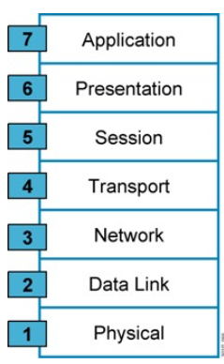

This is OSI model using to design and establish the network

This model includes & layers:

1. Physical :
   * Unstructured bit transmission throughout mechanic, electric, method, procedure
2. Data link :
   * [node-to-node data transfer](https://en.wikipedia.org/wiki/Node-to-node_data_transfer)—a link between two directly connected nodes. It detects and possibly corrects errors that may occur in the physical layer. It defines the protocol to establish and terminate a connection between two physically connected devices. It also defines the protocol for [flow control](https://en.wikipedia.org/wiki/Flow_control_(data)) between them.
3. Network :
   * Choose the shortest way to transfer data
4. Transport:
   * Provides the functional and procedural means of transferring variable-length data sequences from a source to a destination host, while maintaining the quality of service functions.
5. Session:
   * Provide connection between computers. It establishes, manages and terminates the connections between the local and remote application.
6. Presentation :
   * establishes context between application-layer entities, in which the application-layer entities may use different syntax and semantics if the presentation service provides a mapping between them
7. Application :
   * Provide interaction between end user and software application directly.

Methods that are used for transferring data:

* Request : User uses to call a function
* Indicator : Service provider uses to call a function and report functions have been called
* Response : Used for returning a result by a called function earlier by Indicator
* Confirm : Service Provider uses for completing a function called by a user’s Request

OSI Model – How it works :

1. Operating mode with links:

* Set up links : level based on the negotiation of the system
* Transferring data : Data transmission with control and management mechanisms attached to enhance the reliability and efficiency of transmission
* Abort link: release the link to use for another link

1. Dynamic mode without links:

* There is only one stage of transferring data
* Comparing these two:
* With links : allow to transfer reliable data. However, it’s complicated when setting up
* Without links : allow to transfer a variety of data. However, gathering PDU to transfer to users

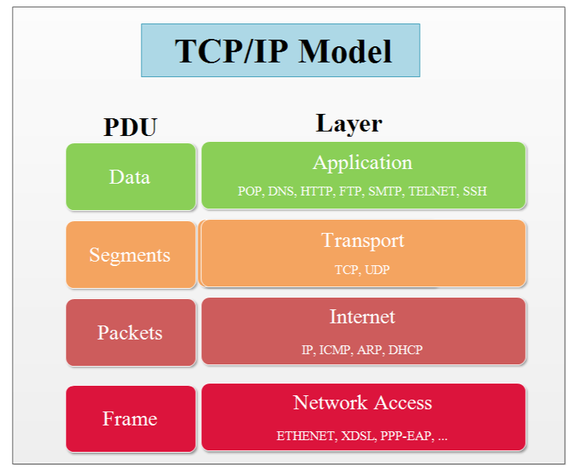

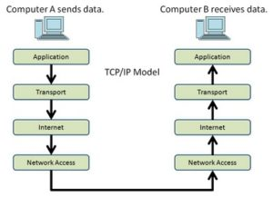

TCP/IP model :

1/ Network Access :

* Receive IP diagram and transfer them in a specific network route
* It is divided into two layers :

+ Physical layer : interact with physical devices and transfer 0-1 bit

+ Data link layer : data is organized into frame, the begin of the frame contains address and control information. The end of the frame is used for detecting errors.

2/ Internet :

* Used for routing the shortest and best way to transfer data.

3/ Transport :

* Directly transfer data (end-to-end) combined with error control, fragmentation and flow control.
  + 1. định hướng kết nối (connection-oriented) for example: TCP
  + 2. phi kết nối (connectionless) for example: UDP

4/ Application:

* Used for interaction between networks